TutorTube: Production Possibilities Curve Fall 2020
Introduction
Hello and welcome to TutorTube, where The Learning Center’s Lead Tutors help you understand challenging course concepts with easy to understand videos. My name is Alyceson-Grace Eke, Lead Tutor for Economics. In today’s video, we will explore Production Possibilities Curve. Let’s get started!
Defining the PPC
First, let’s pose the question: What is the Production Possibilities Curve?
The Production Possibilities Curve, also known as the Production Possibilities Frontier, is a graphical representation of all potential allocations of two resources. The two resources are either capital goods, like guns and machines, or consumer goods, like food and shirts.
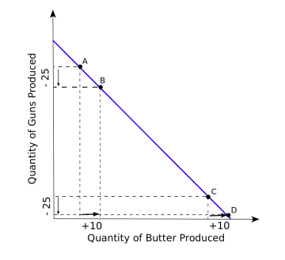
Figure 1

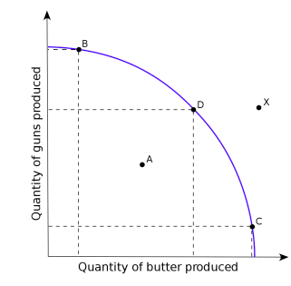
Figure 2

Elements of the Curve
The curve itself can either bow out or stay straight. It will tell whether the goods have perfectly substitutable resources - that’s when it’s straight - or imperfectly substitutable resources - when the curve is bowed out.
The curve also represents opportunity cost. Opportunity cost is the sacrifice one makes for their current decision. The straight line shows a constant opportunity cost and the bowed out line shows an increasing opportunity cost.
Tl;dr - Perfectly substitutable resources have a constant opportunity cost. Imperfectly substitutable resources have an increasing opportunity cost.

Outcomes of the PPC

Let’s draw a PPC. Here are all the potential outcomes of any PPC.
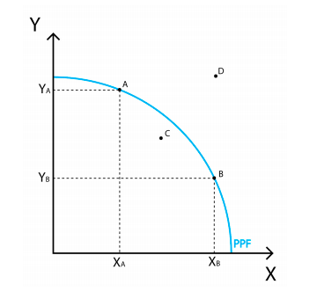

Figure 3

Outcome #1: Inefficiency [Point C]. Any time there is a point within the curve, we are being inefficient. That’s because the curve also shows the most we can produce. Anything below that means we aren’t using all of our resources.
Outcome #2: Efficiency [Points A & B]. If we are along the curve, we are being efficient. We are using all of our resources.
Outcome #3: Impossible Production [Point D]. Any point past the curve is impossible at the time. We do not have the resources to produce the combination suggested. It goes past maximum production, so it’s impossible.

Calculating Opportunity Cost

To calculate the opportunity cost of a good, look at the numbers on the axes and find the number change based on a one unit difference in the good in question.
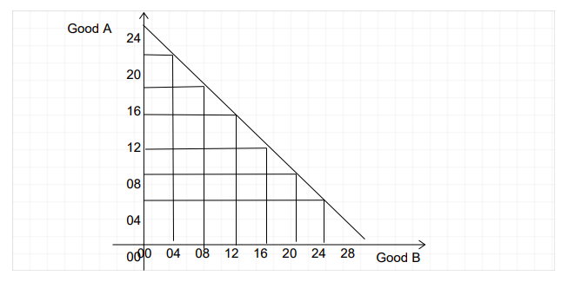
Figure 4

Example 1:
In this graph, the PPF is straight. Let's look at one of the first points on the curve, where you have 24 units of Good A and 4 units of Good B. If we move to the next point, we have 20 units of Good A and 8 units of Good B.
Question: How much of Good A do we have to give up for one unit of Good B?
Let's see. We lost 4 units of Good A and gained 4 units of Good B. How do we know the opportunity cost for one unit of Good B? Set it like a ratio - Good A losses to Good B gains. Then, reduce the ratio until Good B gains are one. Since the ratio is 4:4, we need to reduce the ratio to ?:1 . To do this, divide both parts by 4. 4:4 becomes 1:1. Therefore, for one unit of Good B, we lose one unit of Good A.

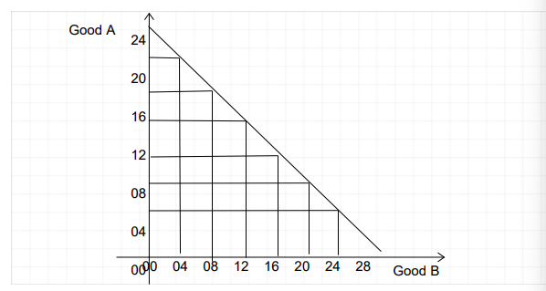
Figure 5
Now, let’s try to do a problem that covers everything you need to know about a PPC.
Scenario: The Kingdom of Sardina produces Abbacchio Donuts and Bruno Bagels. The production possibilities frontier is displayed here:
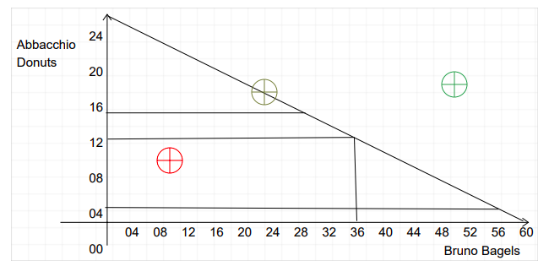
Figure 6

- Are the resources perfectly or imperfectly substitutable?
- Are opportunity costs increasing or constant?
- At the red icon, are we inefficient, impossible, or efficiently producing?
- At the dark yellow icon, are we inefficient, impossible, or efficiently producing?
- At the green icon, are we inefficient, impossible, or efficiently producing?
- We can produce 16 Abbacchio Donuts and 28 Bruno Bagels. Let's say we want toproduce 36 Bruno Bagels, meaning we can only produce 12 Abbacchio Donuts. What is the opportunity cost for one Bruno Bagel?
Answers:
- The resources are perfectly substitutable, as shown by the straight PPF. Any time the PPF is straight, the resources are perfectly substitutable.
- Opportunity Costs are constant, as shown by the straight PPF. If the PPF is straight, the opportunity cost is constant.
- We are inefficient at the red icon. We are not using all of our resources to produce at our maximum.
- We are efficiently producing at the dark yellow icon. We are on the PPF, meaning we have reached our limit of performance.
- We are unable to produce at the green icon because we do not have the resources to produce at that point.
- The opportunity cost for one Bruno Bagel is 1/2 of an Abbacchio Donut. Bruno Bagels increased by 8, and Abbacchio Donuts decreased by 4. We can create the ratio, 8:4, and simplify the ratio where Bruno Bagels equal 1. By dividing both sides by 8, we get 1:1/2.

Outro
Thank you for watching TutorTube! I hope you enjoyed this video. Please subscribe to our channel for more exciting videos. Check out the links in the description below for more information about The Learning Center and follow us on social media. See you next time!

